Month of the Flower Moon
Contradance

DENMARK ARTS CENTER

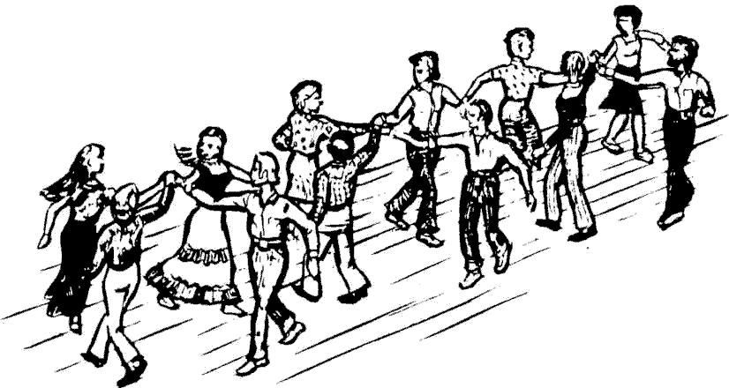

A family-friendly Contradance with Birds on a Wire and caller Eric Rollnick. Teaching session begins the evening for the first half hour. Join Jenny & Greg Huang-Dale, Jeanine Loubier and Eric Rollnick for a Month of the Flower Moon kinda evening!
Denmark Arts Center
50 West Main St. (Route 160)
Saturday, May 19th from 6-9pm
$10 donation suggested

